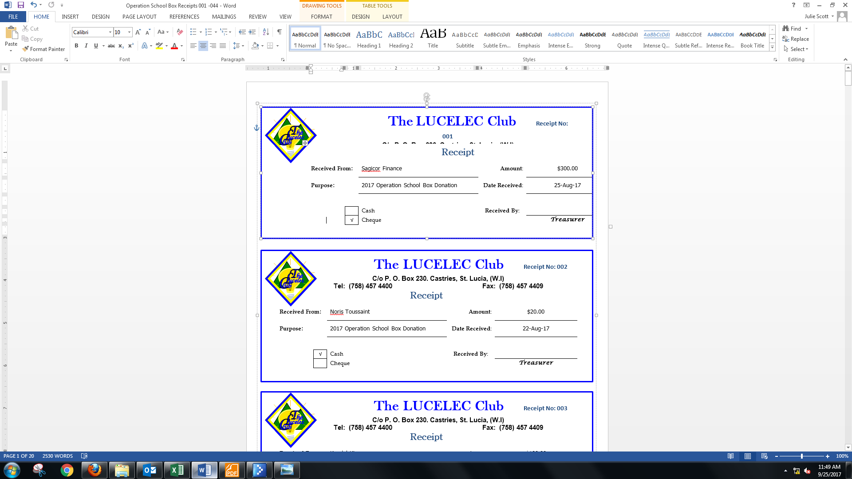
The LUCELEC Club
P.O. Box 230
John Compton Highway, Castries
1-758-457-4400 lucelecclub@lucelec.com

SALARY DEDUCTION FORM

I _______________________________ of the ______________________ Department, hereby give permission for the one time deduction in the amount of EC ______________ from my salaries/wages as payment for _________________________ to the LUCELEC Club.

Signed _____________________________ Date: ______________________________

Club Treasurer: ______________________ Payroll Officer: ______________________

